Gian Russell D. VIllegas BSIT 3-C IT Elec 1 – Web Development

Documentation: Robiel Prince Café Website using “Populating Pages”

1. Overview:  
The Robiel Prince Café website simulates a dynamic café application built with Laravel. It features:

* A homepage showcasing the café’s highlights and best sellers.
* A menu page listing all available items with ratings, prices, and images.
* Dynamic routing to personalize the user experience (e.g., username in URL).

2. Rendered Web Pages:

A. Home Page

homepage.blade.php  
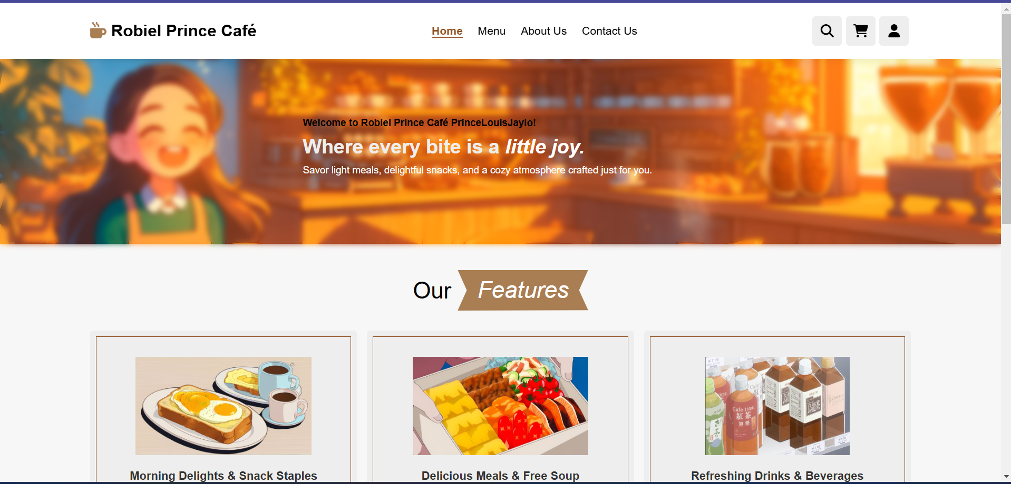  
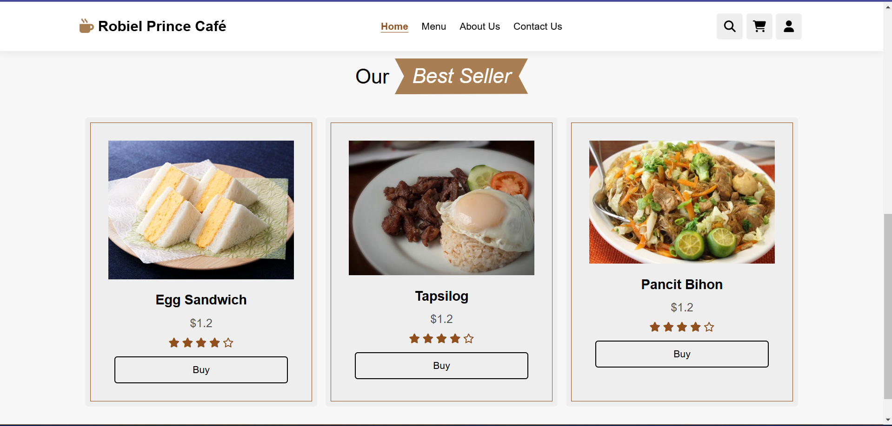  
The homepage greets the user by name for example my name PrinceLouisJaylo and highlights the café’s main features, including best sellers with dynamic data passed from the controller.

B. Menu Page

menupage.blade.php  
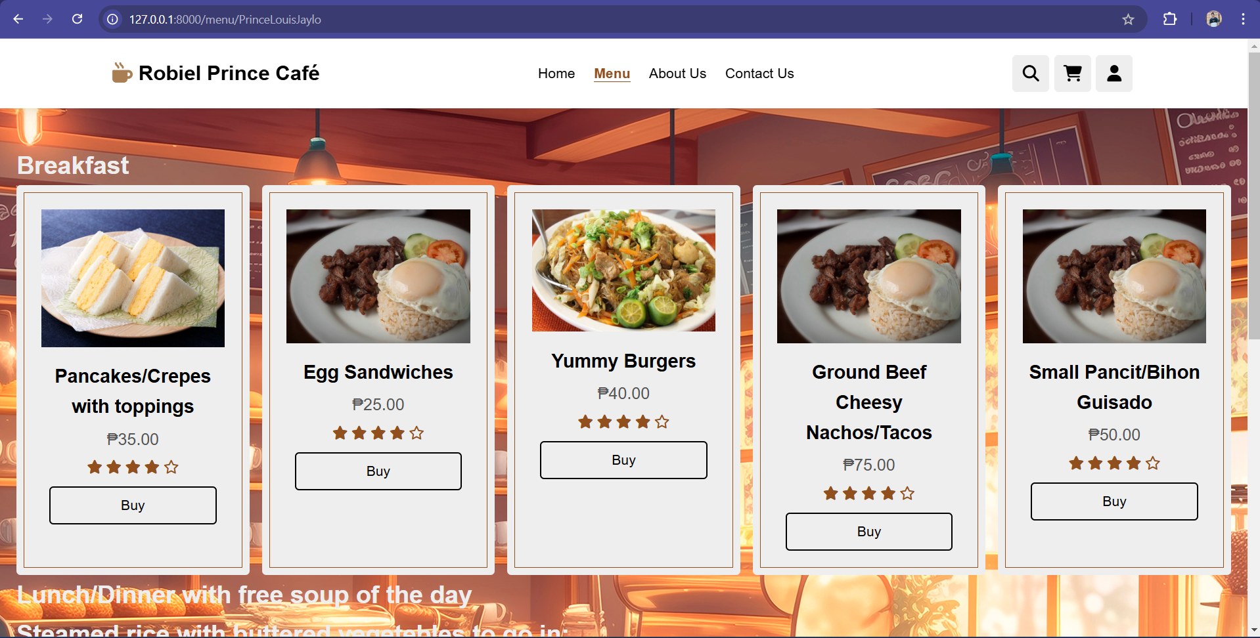  
The menu page displays a dynamically loaded list of food items. Each item shows an image, name, price, and rating, fetched via the controller.

3. Controllers:

A. HomePageController.php  
  
Logic Explanation:

* Simulates fetching "Best Seller" items from a database as an array.
* Uses $username parameter to personalize the user experience.
* Passes the bestSellers data and username to the Blade view.

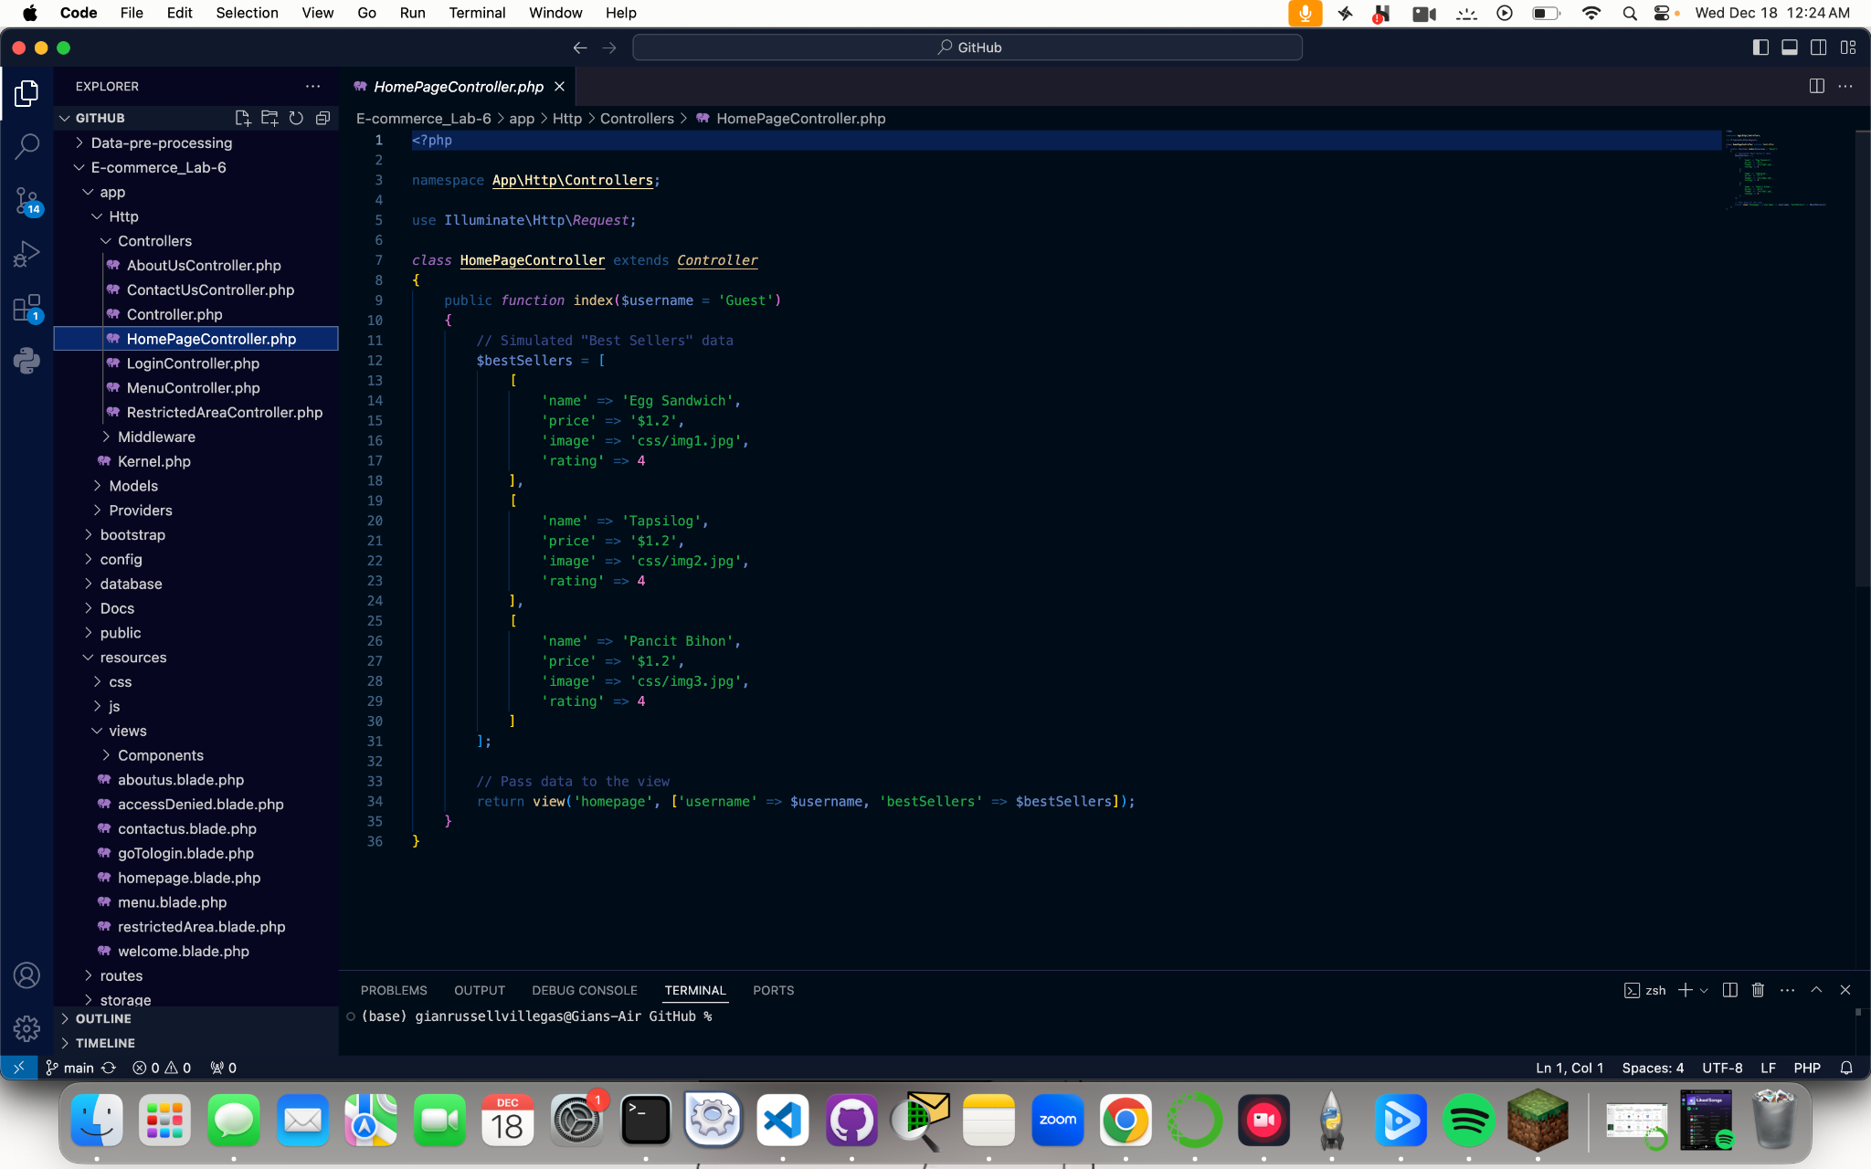

B. MenuController.php  
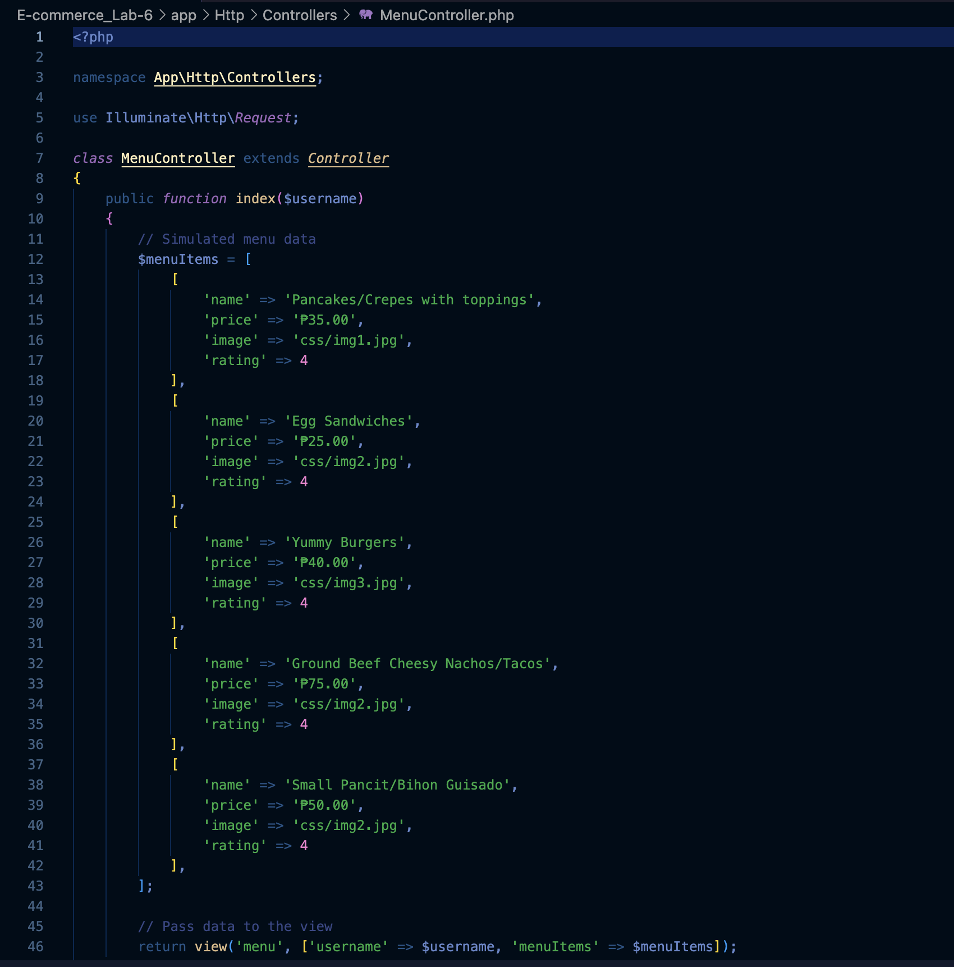  
  
Logic Explanation:

* Simulates fetching menu data as an array.
* Passes the menuItems array and $username parameter to the Blade view.

4. Routes:  
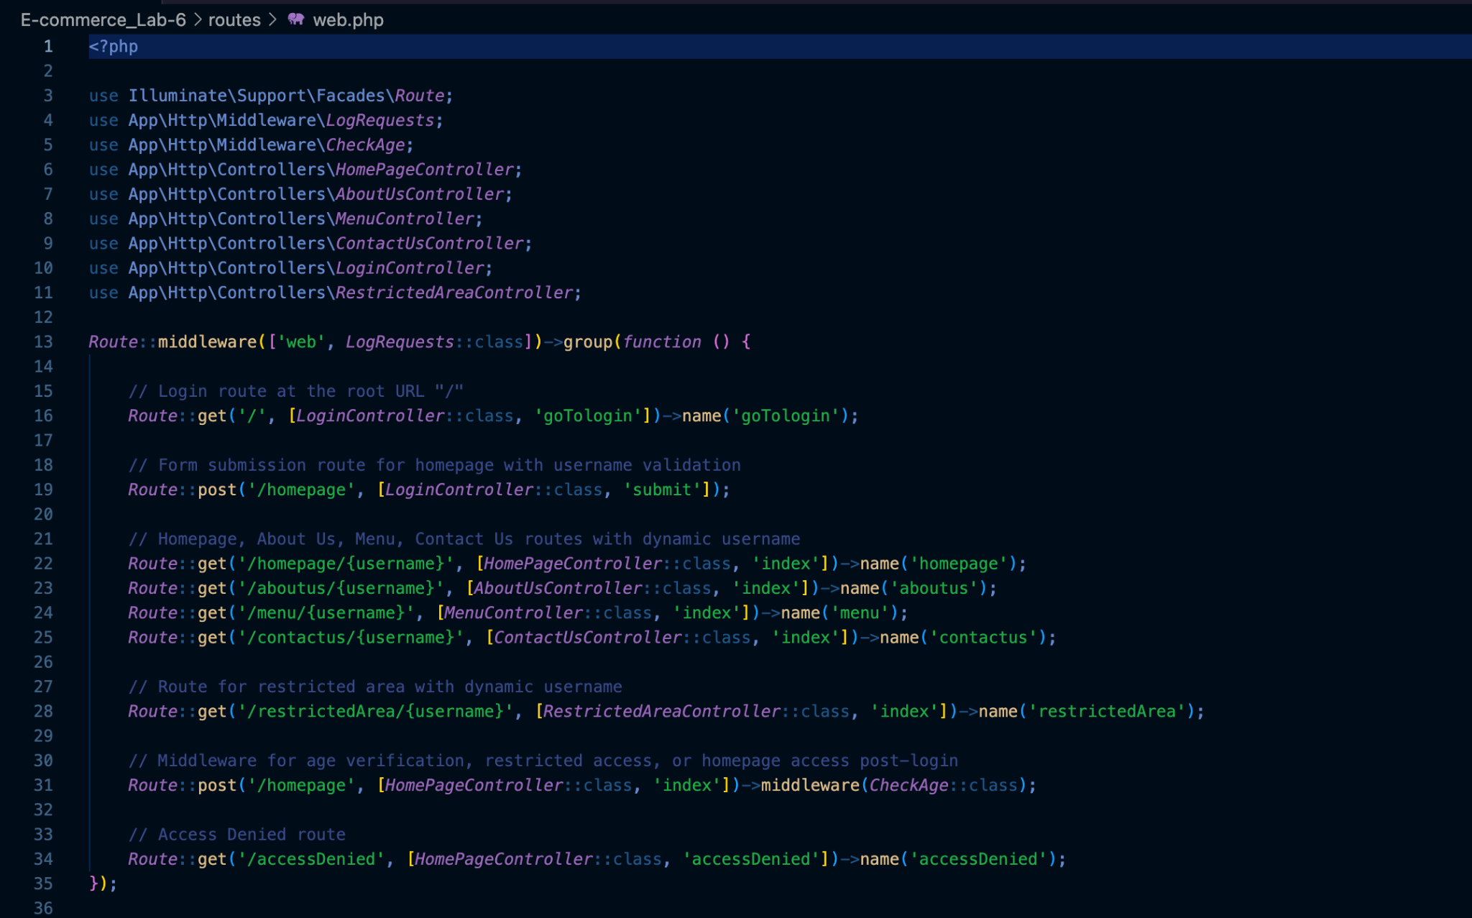  
  
Explanation:

* Both routes use dynamic URL parameters ({username}) to pass the username to the controllers.
* The controllers handle these parameters and pass them to the corresponding Blade views.

5. Blade Templates:

A. homepage.blade.php  
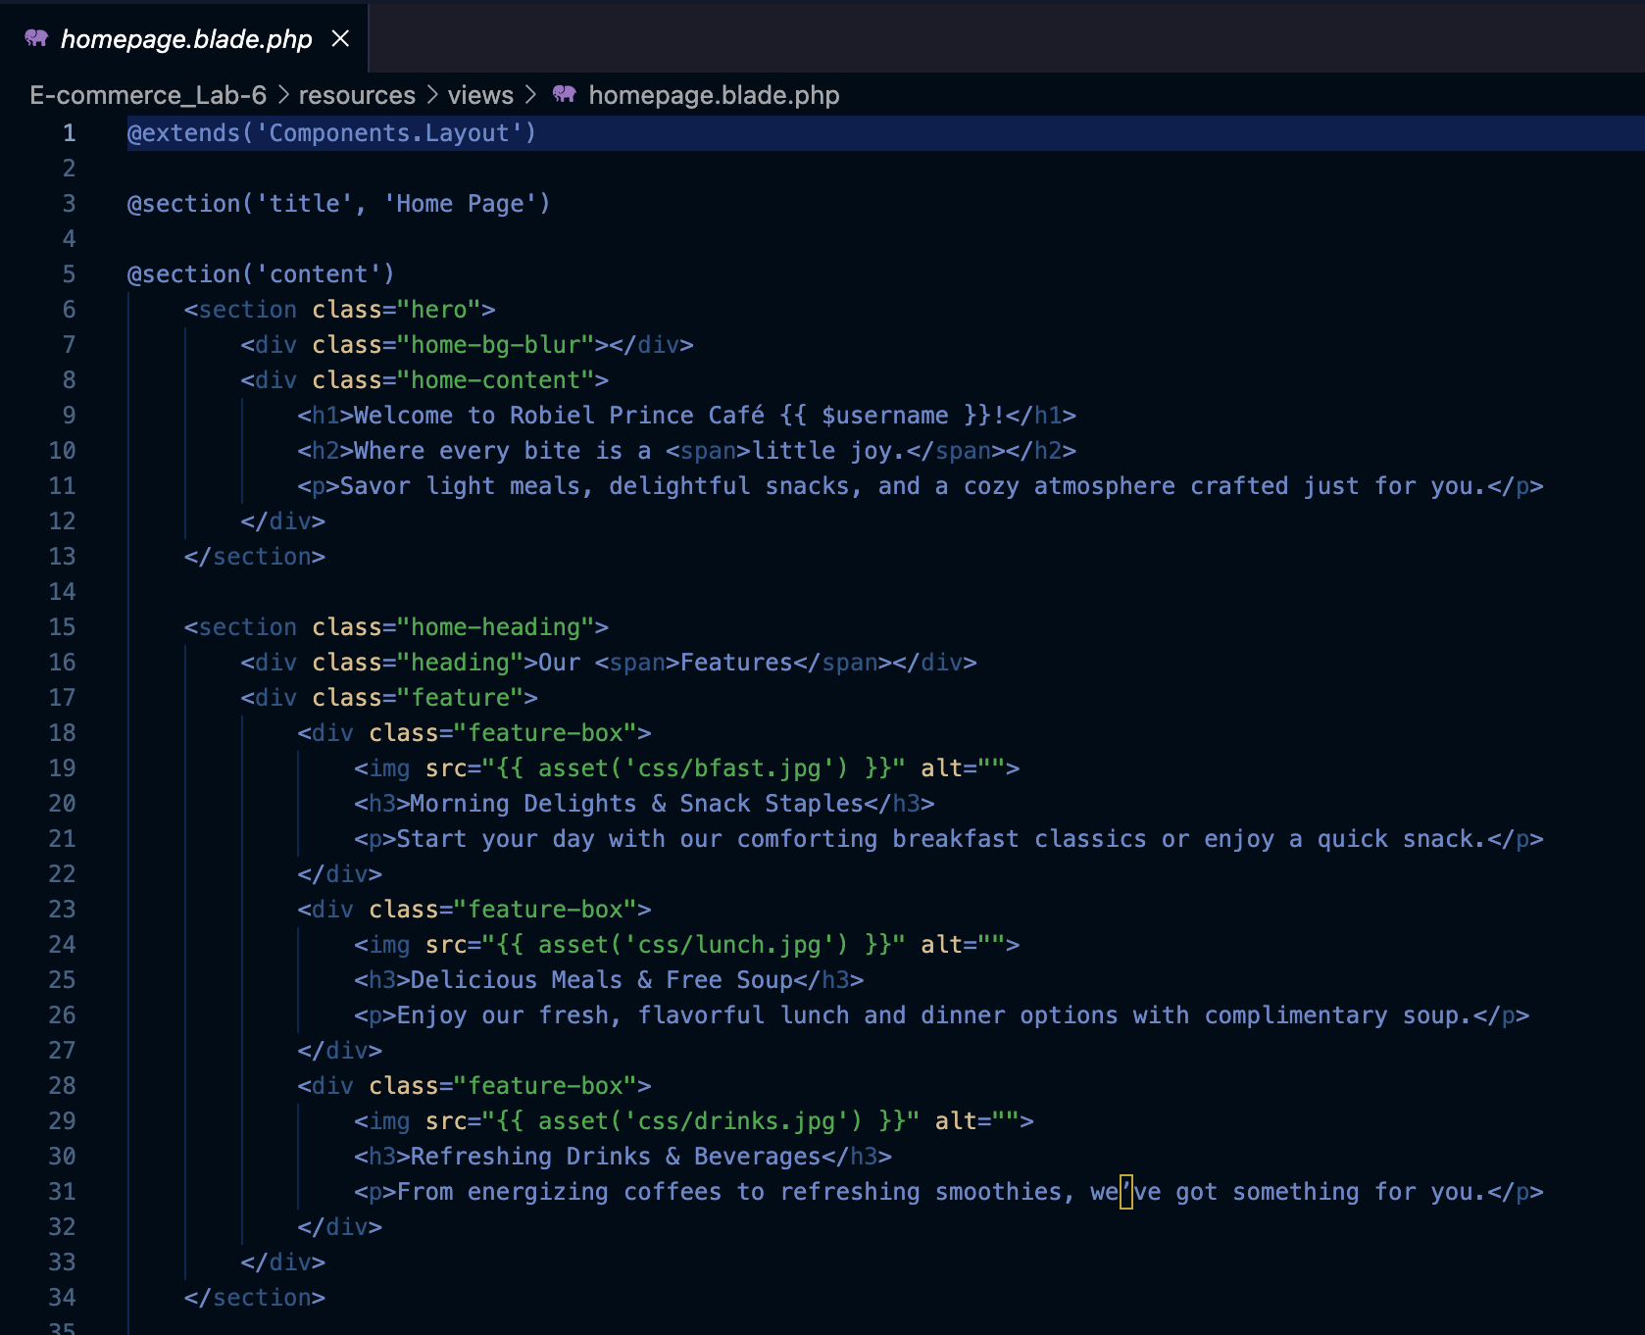  
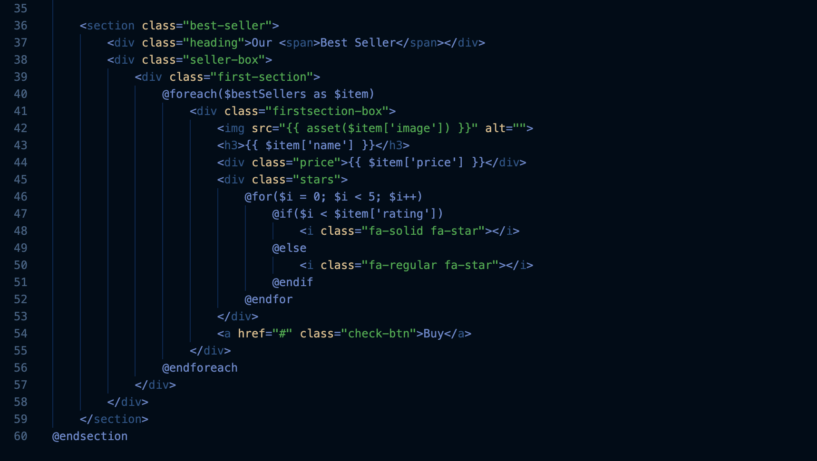

Description:

* Loops through the menuItems array passed from the MenuController.
* Dynamically renders menu items with personalized content.

B. menu.blade.php  
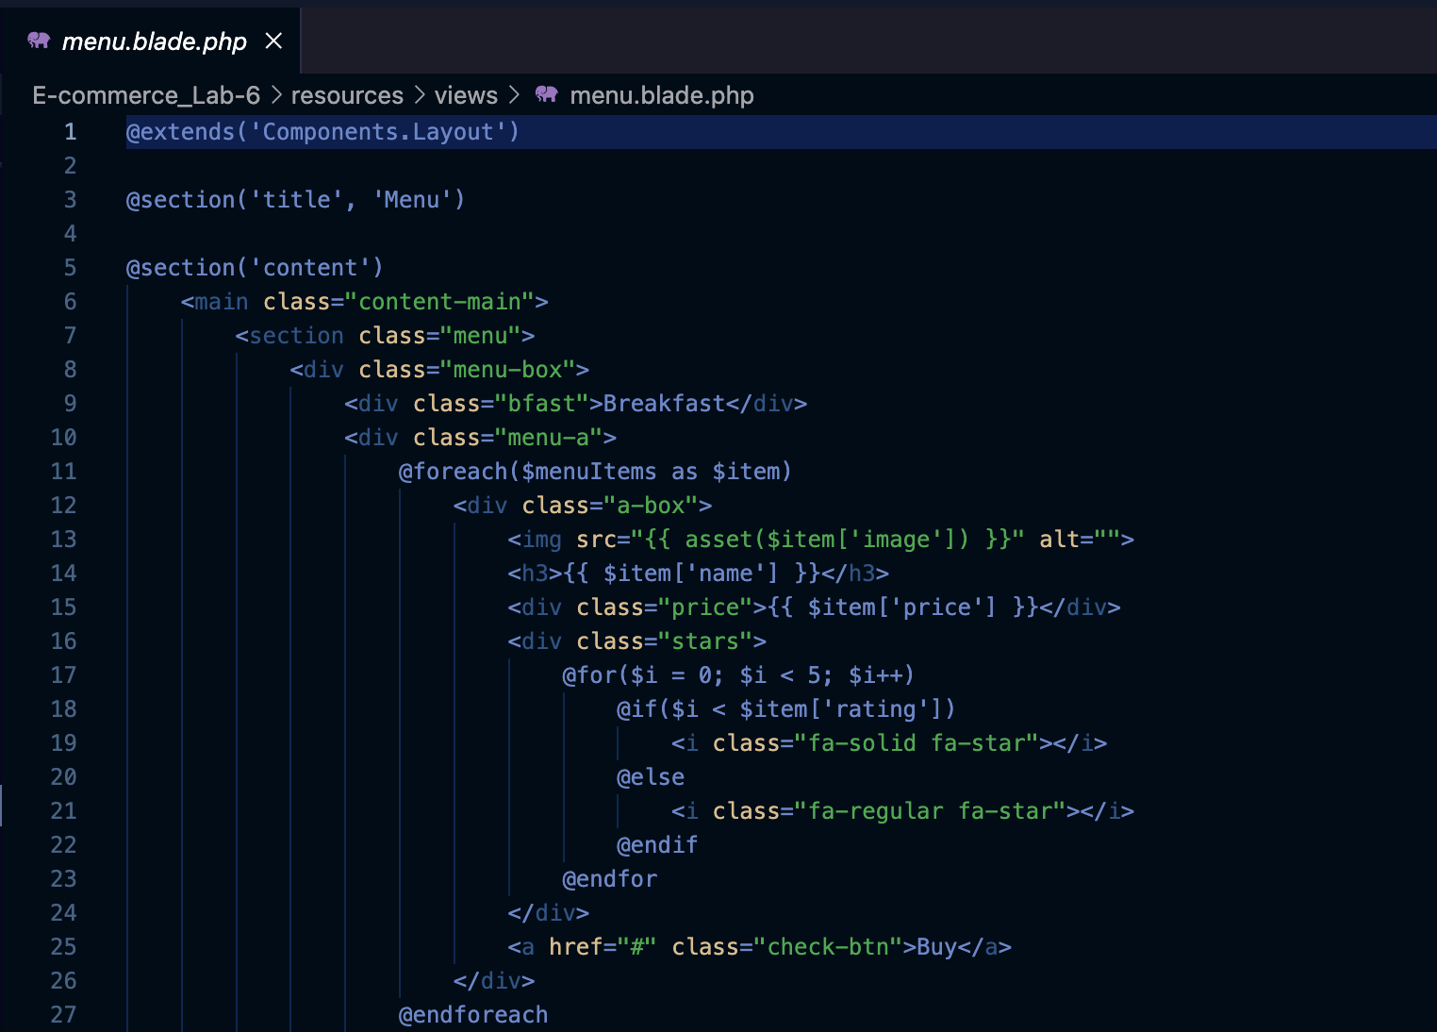  
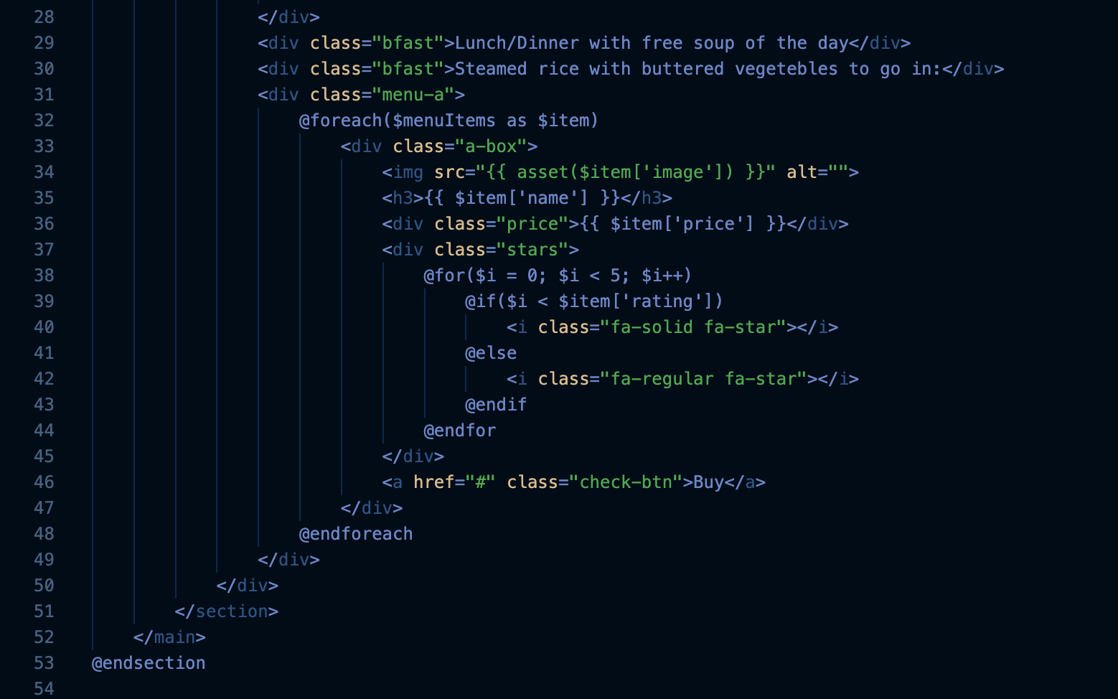  
Description:

* Loops through the menuItems array passed from the MenuController.
* Dynamically renders menu items with personalized content.

6. Things I have learned in this activity:

1. Dynamic Routing: Using parameters in routes enables personalized content delivery.
2. Blade Templates: Simplifies dynamic rendering of data using loops and conditionals.
3. Simulated Database Access: Data arrays effectively replicate database content during development.
4. Reusability: Laravel controllers and views facilitate modular development, making the code reusable.